MICROSOFT BLUETOOTH MOBILE KEYBOARD 5000
December 2011
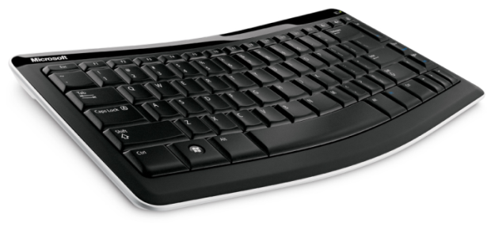

The Microsoft Bluetooth Mobile Keyboard 5000 is the perfect balance of portability and comfort. The Bluetooth wireless technology allows connection to Windows-based tablets, iPad and iPad 2, and many Android tablet devices without cords or USB nano transceivers, thereby freeing up a USB port.¹ The lightweight, slim design of this full-sized keyboard makes it convenient to carry without compromising durability. The high-quality construction of the keyboard is designed for travel and mobility. With the Bluetooth Mobile Keyboard 5000, you can type easily on a plane, capture notes in a conference room or catch up on personal email from the couch.

Featuring an ergonomist-approved “Comfort Curve” design,² the Bluetooth Mobile Keyboard 5000 promotes a more natural wrist posture, is easy to use across many devices and makes a perfect tablet companion.
Ergonomic Design 101 — Questions you always wanted to ask …

Why should people care about ergonomic design?
People should prioritize finding a mouse and keyboard that work well for their bodies and their work environments. This can help you to be more comfortable, be more productive and ultimately enjoy working with your computer more.

How does Microsoft’s Comfort Curve make a difference?
The curved shape of Microsoft ergonomic keyboards promotes a more natural hand, wrist and forearm posture.

Learn more about Healthy Computing by visiting the Microsoft Hardware website.
Dr. Dan Odell
Certified Professional Ergonomist and
Microsoft’s resident comfort expert
Top Features and Benefits

- New! Tablet compatibility with Windows, iPad and iPad 2, and many Android tablet devices
- Ergonomist-approved “Comfort Curve” design promotes a more natural wrist posture
      - Bluetooth wireless frees up a USB port by easily connecting to a Bluetooth-enabled computer, and no USB nano transceiver is needed
- Ultrathin, stylish design makes it lightweight and portable for travel
- Three-year limited hardware warranty

Read on for more information about the following:
Top-Line System Requirements / Availability and Pricing / Contact Info
Top-Line System Requirements
To use the Bluetooth Mobile Keyboard 5000, consumers need the following:
For a Windows-based PC | For Macintosh
- Windows 7, Windows Vista, Windows XP with Service Pack (SP2) or later  - 2 AAA alkaline batteries (included)  - Supported device enabled with Bluetooth version 2.0 | - Mac OS X v.10.4–10.5.x  - 2 AAA alkaline batteries (included)  - Supported device enabled with Bluetooth version 2.0
Works with iOS 4.2.1, 4.3.1 and 4.3.2. Works with Android 2.2 (Froyo), 3.0 and 3.1 (Honeycomb).¹

Availability and Pricing

Microsoft Bluetooth Mobile Keyboard 5000 will be available in December 2011 for an estimated retail price of $49.95 (U.S.).³

The Bluetooth Mobile Keyboard 5000 is backed by a three-year limited hardware warranty. The limited warranty and license agreement are available at http://www.microsoft.com/hardware/warranty.

¹ Basic keyboard functionality with iOS 4.2.1, 4.3.1, and 4.3.2, Android 2.2 (Froyo), and Android 3.0 and 3.1 (Honeycomb). Some advanced keyboard functionality (including function keys and keyboard shortcuts designed for Windows) and special iOS and Android features are not available when using keyboard with iOS and Android devices.
² Approved by Dan Odell, Ph.D., C.P.E., Microsoft Design Ergonomist
³ Actual retail price may vary.

Contact Information

For more information, press only:
Alyson Davis, Edelman, +1-206-268-2236, alyson.davis@edelman.com

For more product information and images:
The Microsoft News Center is available at http://www.microsoft.com/news.

For more information about Microsoft Hardware:
The Microsoft Hardware blog is available at http://www.microsofthardwareblog.com.

