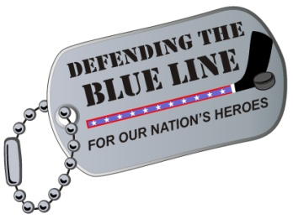

PLEDGE FORM

SKATE FOR THE TROOPS!

Sunday, February 27th 4-9:00pm

Eagan Civic Ice Arena

Eagan, MN

### Donor Information (please print or type)

|  |  |
| --- | --- |
| Name |  |
| Billing address |  |
| City |  |
| State |  |
| ZIP Code |  |
| Telephone (home) |  |
| Telephone (business) |  |
| E-Mail |  |
| Add to DTBL Mailing List? |  |

### Pledge Information

I (we) pledge a total of $

I (we) plan to make this contribution in the form of:  
 cash check credit card other.

|  |  |
| --- | --- |
| Credit card type |  |
| Credit card number |  |
| Expiration date |  |
| Authorized signature |  |

Gift will be matched by (company/family/foundation).  
 form enclosed form will be forwarded

### Acknowledgement Information

Please use the following name(s) in all acknowledgements:

|  |
| --- |
|  |

I (we) wish to have our gift remain anonymous.

|  |
| --- |
| Signature(s) |
| Date |

Please make checks, corporate matches, or other gifts payable to:

Defending The Blue Line 

**1206 N. Frontage Road, Suite B Sponsored By:**

**Hastings, MN 55033 Minnesota NHL Alumni Association**

Tax ID#: 27-0711063